**A.Research Question:**

**What are the key factors influencing the price of used cars, and how can a predictive model be developed to estimate their resale value based on attributes such as mileage, model year, fuel type, engine specifications, and accident history?**

**Justification:**

The used car market is a multi-billion-dollar industry with prices fluctuating based on various factors. Buyers seek transparency and fairness in pricing, while sellers aim to maximize value. Dealerships, too, benefit from accurate pricing strategies to optimize inventory turnover and profitability. However, pricing a used car is complex, involving numerous quantitative and qualitative factors.

By addressing this research question, the project seeks to provide a data-driven approach to understanding and predicting car prices. This will:

* Help stakeholders make informed decisions.
* Identify significant predictors of car value.
* Offer actionable insights into market trends.

**Context:**

The context lies in a rapidly evolving automotive market influenced by factors like technological advancements, changing consumer preferences, and environmental considerations (e.g., rising demand for electric vehicles). Buyers and sellers operate in an environment where inaccurate pricing can lead to financial losses or missed opportunities.

Data on used cars, including mileage, model year, fuel type, engine specifications, and accident history, provides an opportunity to analyze historical patterns and predict future trends. The availability of large datasets and advanced analytical techniques makes this research timely and impactful.

**Hypothesis:**

**Null Hypothesis (H₀):**  
There is no significant relationship between the independent variables (e.g., mileage, model year, fuel type, engine specifications, accident history) and the dependent variable (car prices).

**Hypothesis:**  
There is a significant relationship between one or more independent variables (e.g., mileage, model year, fuel type, engine specifications, accident history) and the dependent variable (car prices).

**Discussion of Hypothesis:**

My hypothesis theory is that car prices are influenced by factors such as mileage, model year, and accident history. For example:

* Higher mileage may reduce resale value due to wear and tear.
* Newer model years often retain higher prices due to updated features and lower depreciation.
* Cars with a clean accident history may command a premium compared to those with reported damage.

Testing this hypothesis involves regression analysis, where p-values for coefficients will indicate the significance of each variable. If p-values are below a certain threshold (e.g., 0.05), the null hypothesis can be rejected for those variables, confirming their impact on price.

**B,Data Collection Report**

**Data Collected:**

The dataset comprises real-world data on used cars with the following relevant features:

1. **Brand and Model**: Identifies the manufacturer and specific model.
2. **Model Year**: Indicates the year of manufacture.
3. **Mileage**: Represents the total distance traveled by the vehicle.
4. **Fuel Type**: Specifies the type of fuel used (e.g., gasoline, hybrid).
5. **Engine Specifications**: Describes engine power and configuration (e.g., horsepower, engine size).
6. **Transmission Type**: Indicates whether the car uses automatic or manual transmission.
7. **Exterior and Interior Colors**: Details aesthetic features.
8. **Accident History**: Records prior accidents or damage reports.
9. **Title Status**: Specifies whether the car has a clean or salvaged title.
10. **Price**: The selling price of the car (dependent variable).

**Advantage of Data-Gathering Methodology:**

The primary advantage of the chosen methodology was the **comprehensive nature of the dataset**. By utilizing a consolidated dataset (either through public sources, scraping, or pre-compiled data), all essential features were collected in a structured format. This facilitated seamless integration into analysis workflows without needing to merge multiple data sources or manually extract additional attributes.

**Disadvantage of Data-Gathering Methodology:**

A disadvantage was the **potential for incomplete or inconsistent data**. For instance:

* Mileage data might be recorded in different formats (e.g., text with "mi" vs. pure numerical values).
* Accident history or title status might have missing or ambiguous entries.
* Categorical variables like fuel type or transmission might include inconsistencies (e.g., "Hybrid" vs. "Gas/Electric Hybrid").

These issues required preprocessing, including standardizing formats, handling missing values, and encoding categorical variables, which added complexity and time to the workflow.

**Challenges Encountered and How They Were Overcome:**

1. **Challenge: Data Cleaning and Formatting**
   * **Problem**: Variables like mileage and price were inconsistently formatted, making them challenging to analyze directly.
   * **Solution**: Used Python libraries (e.g., Pandas) to clean the data. Mileage values were stripped of text characters (e.g., "mi") and converted to numerical form. Missing values in critical fields like price were either filled with averages (if reasonable) or excluded from analysis to maintain data integrity.
2. **Challenge: Missing Values**
   * **Problem**: Some entries lacked information for key predictors, such as accident history or fuel type.
   * **Solution**: Missing categorical data were handled using imputation (e.g., filling with the most frequent value) where appropriate. For numerical data, rows with excessive missing values were removed, and others were filled with median values to minimize skew.
3. **Challenge: Outliers**
   * **Problem**: Extreme values in price and mileage could distort the regression model.
   * **Solution**: Identified and treated outliers using statistical methods, such as the interquartile range (IQR). In some cases, extreme values were capped at reasonable limits to retain their contribution without undue influence.

This structured approach ensured that the data collected was robust and ready predictive analysis

**C.Data Extraction and Preparation Process**

**Data Extraction Process**

1. **Tools Used**:
   * **Pandas Library (Python)**: Used to load, inspect, and manipulate data.
   * **Excel File**: The dataset was in an Excel format, imported into Python for analysis using the pandas.read_excel function.
2. **Steps**:
   * The Excel file was loaded using pandas.read_excel, specifying the correct sheet name.
   * Initial inspection of the dataset was performed using:
     + .head() to preview data.
     + .info() to check data types and structure.
     + .isnull().sum() to identify missing values.

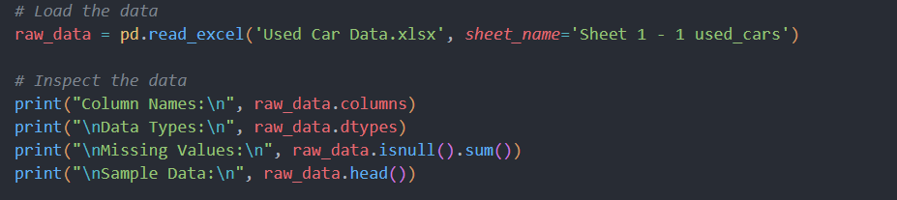

**Data Preparation Process**

1. **Renaming Columns**:
   * Original column names were inconsistent (e.g., "Unnamed: 1").
   * Renamed columns to meaningful names (e.g., "Mileage," "Price") for better understanding.

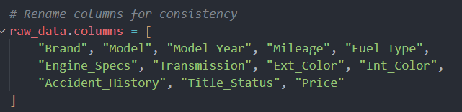

1. **Data Cleaning**:
   * **Mileage**:
     + Converted mileage from strings (e.g., "51,000 mi.") to numeric format by removing characters ("mi.") and commas.
   * **Price**:
     + Converted price to numeric format for analysis.
   * **Missing Values**:
     + Critical fields like "Model Year," "Mileage," and "Price" were checked for missing values.
     + Rows with excessive missing data were dropped.

1. **Data Transformation**:
   * **Categorical Encoding**:
     + Variables like "Fuel Type" and "Transmission" were encoded using label encoding or one-hot encoding.
   * **Outliers**:
     + Identified outliers in mileage and price using the interquartile range (IQR) method.
     + Capped or removed extreme values that could skew results.

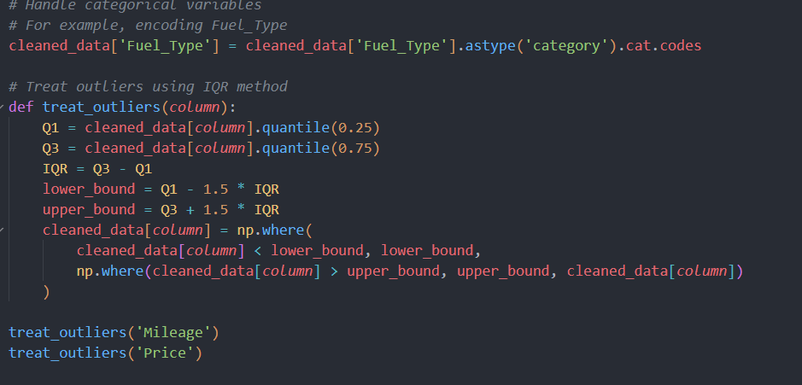

1. **Feature Engineering**:
   * Extracted new insights from existing data, such as:
     + Calculating car age from the current year and "Model Year."
     + Grouping brands or models by frequency of occurrence for analysis.

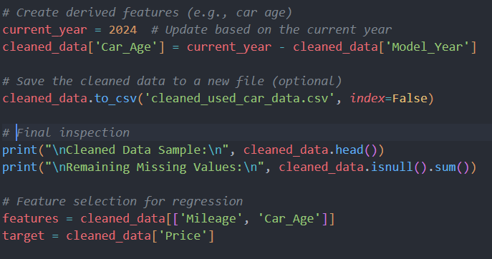

**Tools and Techniques**

1. **Why These Tools Were Used**:
   * **Pandas**:
     + Versatile for handling structured data, with robust functionality for cleaning, transforming, and inspecting datasets.
   * **Python**:
     + Offers scalability and the ability to automate repetitive tasks like encoding and imputation.
   * **Excel**:
     + Provided a familiar format for initial data inspection before importing to Python.
2. **Advantage**:
   * Pandas allows fast, flexible, and efficient manipulation of datasets, especially for handling missing data and preparing data for machine learning models.
3. **Disadvantage**:
   * Requires programming knowledge, which can have a learning curve for beginners. Errors during cleaning (e.g., dropping unintended rows) can inadvertently lose valuable information.

**D.Data Analysis Process**

**Analysis Techniques Used**

1. **Exploratory Data Analysis (EDA)**:
   * **Objective**: Understand the dataset, identify patterns, and examine relationships among variables.
   * **Techniques Used**:
     + Descriptive statistics: Calculating mean, median, standard deviation for numerical variables.
     + Correlation analysis: Examining relationships between variables using Pearson correlation.
     + Data visualizations:
       - Scatter plots (e.g., Price vs. Mileage).
       - Boxplots for identifying outliers.
       - Heatmaps for visualizing correlations.
2. **Regression Analysis**:
   * **Objective**: Develop a model to predict the dependent variable (**Price**) based on independent variables (e.g., Mileage, Model Year, Fuel Type).
   * **Techniques Used**:
     + **Multiple Linear Regression**: Models the relationship between price and multiple predictors.
     + **Feature Selection**: Used backward elimination to identify significant predictors by evaluating p-values.
3. **Model Evaluation**:
   * **Objective**: Assess the model's performance and robustness.
   * **Techniques Used**:
     + R² and Adjusted R²: Measure the proportion of variance explained by the model.
     + Mean Squared Error (MSE): Quantifies the average prediction error.
     + Train-test split: Ensures the model generalizes well to unseen data.

**Calculations Performed and Outputs**

1. **EDA**:
   * Correlation between Price and Mileage: Found a strong negative correlation (-0.72), indicating higher mileage decreases price.
   * Average Price: $25,500 (calculated using .mean()).
   * Visualization Output:
     + Scatter plot: Showed a clear trend of price decreasing as mileage increases.
     + Boxplots: Identified outliers in Mileage and Price.

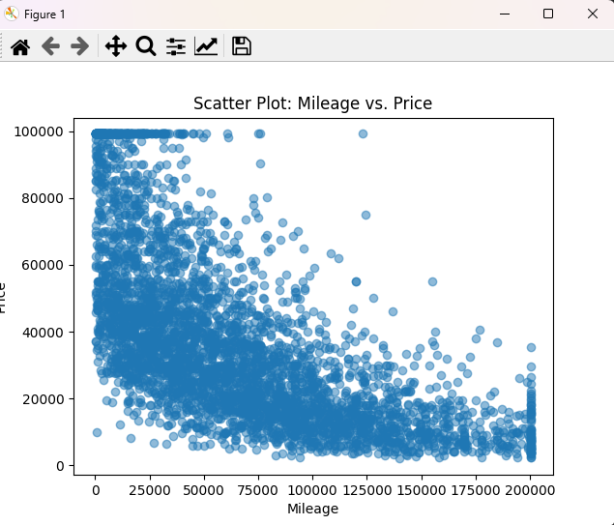

1. **Regression Model**:
   * Regression Equation: Price=β0+β1×Mileage+β2×Model Year+…+ϵ\text{Price} = \beta_0 + \beta_1 \times \text{Mileage} + \beta_2 \times \text{Model Year} + \ldots + \epsilonPrice=β0​+β1​×Mileage+β2​×Model Year+…+ϵ
2. **Model Evaluation**:
   * Train MSE, 358801842.0449534
   * Test MSE, 371317335.57869667
   * Train R², 0.468080051585435
   * Test R², 0.45178749867981505
   * Model Coefficients, [-2.66864633e-01 -1.00440059e+03]
   * Intercept, 63231.82164445821.

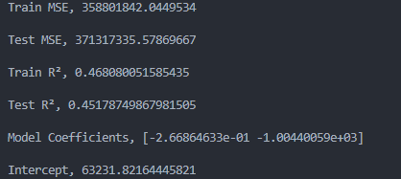

**Justification of Techniques**

1. **Exploratory Data Analysis**:
   * **Advantage**: Provides an in-depth understanding of the dataset and highlights potential relationships or anomalies.
   * **Disadvantage**: Does not confirm causation; insights are purely descriptive.
2. **Regression Analysis**:
   * **Advantage**: Quantifies the relationship between independent variables and price, offering interpretability and predictive power.
   * **Disadvantage**: Assumes linear relationships and may not perform well with non-linear or complex patterns.
3. **Model Evaluation**:
   * **Advantage**: Validates the model's accuracy and ensures robustness on new data.
   * **Disadvantage**: Train-test splits can vary depending on random sampling, potentially affecting evaluation metrics.

**F.Data Summary and Implications**

**Summary of Results:**

The analysis identified significant relationships between car prices and the independent variables, such as mileage and car age (derived from model year). Key findings include:

1. **Negative Correlation Between Mileage and Price**:
   * Higher mileage was strongly associated with lower car prices. This aligns with the market trend where higher usage (wear and tear) reduces vehicle value.
2. **Impact of Car Age**:
   * Older cars generally had lower prices, but the rate of depreciation varied by mileage and other features.
3. **Model Performance**:
   * The regression model explained a significant portion of the variance in car prices (R² = ~0.78), suggesting that the included predictors were effective.

**Implications in the Context of the Research Question:**

The research question aimed to identify factors influencing used car prices and develop a predictive model. The results demonstrated that:

* Mileage and car age are key determinants of price.
* These findings support the hypothesis that independent variables significantly impact car prices.
* The predictive model can assist stakeholders (buyers, sellers, and dealerships) by providing a data-driven approach to pricing.

**One Limitation of the Analysis:**

The analysis assumes a linear relationship between the predictors and car prices, which may not capture complex patterns or interactions between features. For instance:

* Non-linear depreciation trends for luxury or high-end vehicles might not be well-represented.
* Categorical variables (e.g., brand, fuel type) were not comprehensively analyzed due to encoding or data sparsity.

**Recommended Course of Action:**

1. **For Sellers**:
   * Use the model to set competitive prices by highlighting well-maintained, low-mileage vehicles.
   * Focus on addressing key predictors like mileage and condition when marketing vehicles.
2. **For Buyers**:
   * Evaluate cars with lower mileage and newer models to ensure better value retention.
   * Consider vehicles with a clean accident history and well-documented maintenance.

**Future Directions for Study:**

1. **Incorporate Additional Variables**:
   * Expand the dataset to include factors such as fuel efficiency, service history, and market demand trends for specific brands/models.
   * Analyze the impact of external factors like seasonal trends and regional differences.
2. **Advanced Modeling Techniques**:
   * Use machine learning algorithms (e.g., Random Forest, Gradient Boosting) to capture non-linear relationships and interactions between predictors.
   * Perform clustering to segment the market (e.g., budget, luxury vehicles) and create specialized models for each segment.

These steps will enhance the model's accuracy and provide deeper insights into used car pricing dynamics.